**Homework #3 Report**

Hoaxing Wang

#932359049

*Part 1 – 5 Fundamental matrices F(0)*

**10 points for each pair of images selected manually:**

Image 1:

|  |  |  |  |  |
| --- | --- | --- | --- | --- |
| Image 1 | |  | Image 2 | |
| 356 | 412 |  | 375 | 410 |
| 223 | 165 |  | 258 | 165 |
| 152 | 355 |  | 185 | 356 |
| 46 | 390 |  | 89 | 392 |
| 517 | 428 |  | 530 | 429 |
| 140 | 470 |  | 173 | 470 |
| 850 | 502 |  | 857 | 505 |
| 361 | 276 |  | 384 | 280 |
| 495 | 62 |  | 507 | 64 |
| 962 | 534 |  | 992 | 540 |

Image 2:

|  |  |  |  |  |
| --- | --- | --- | --- | --- |
| Image 1 | |  | Image 2 | |
| 349 | 138 |  | 387 | 137 |
| 382 | 265 |  | 410 | 264 |
| 526 | 234 |  | 554 | 234 |
| 184 | 254 |  | 212 | 253 |
| 74 | 536 |  | 73 | 537 |
| 684 | 377 |  | 707 | 376 |
| 604 | 440 |  | 627 | 440 |
| 65 | 197 |  | 98 | 197 |
| 532 | 166 |  | 567 | 166 |
| 310 | 8 |  | 333 | 9 |

Image 3:

|  |  |  |  |  |
| --- | --- | --- | --- | --- |
| Image 1 | |  | Image 2 | |
| 34 | 101 |  | 22 | 102 |
| 48 | 26 |  | 20 | 25 |
| 139 | 4 |  | 113 | 3 |
| 233 | 64 |  | 213 | 66 |
| 21 | 169 |  | 11 | 172 |
| 62 | 327 |  | 57 | 331 |
| 177 | 304 |  | 173 | 304 |
| 239 | 187 |  | 229 | 188 |
| 123 | 189 |  | 120 | 188 |
| 237 | 136 |  | 226 | 137 |

Image 4:

|  |  |  |  |  |
| --- | --- | --- | --- | --- |
| Image 1 | |  | Image 2 | |
| 239 | 98 |  | 233 | 97 |
| 108 | 201 |  | 113 | 199 |
| 279 | 160 |  | 278 | 158 |
| 151 | 157 |  | 151 | 155 |
| 36 | 11 |  | 33 | 11 |
| 96 | 36 |  | 97 | 36 |
| 241 | 44 |  | 234 | 44 |
| 291 | 48 |  | 282 | 48 |
| 54 | 82 |  | 50 | 82 |
| 61 | 73 |  | 55 | 72 |

Image 5:

|  |  |  |  |  |
| --- | --- | --- | --- | --- |
| Image 1 | |  | Image 2 | |
| 386 | 113 |  | 351 | 112 |
| 152 | 189 |  | 117 | 190 |
| 66 | 56 |  | 30 | 56 |
| 78 | 126 |  | 42 | 126 |
| 113 | 180 |  | 78 | 182 |
| 278 | 64 |  | 243 | 63 |
| 171 | 27 |  | 136 | 27 |
| 312 | 131 |  | 278 | 131 |
| 205 | 155 |  | 200 | 153 |
| 254 | 193 |  | 237 | 193 |

**5 Fundamental Matrices:**

Image 1:

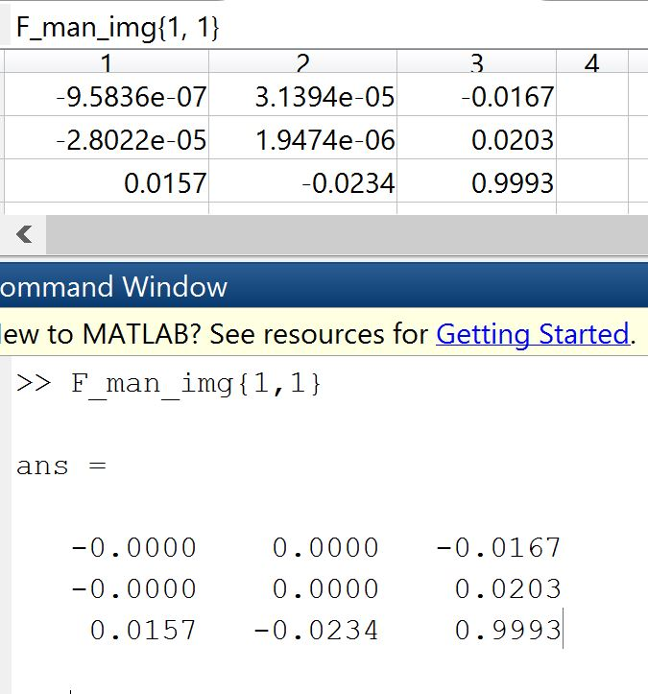

Image 2:

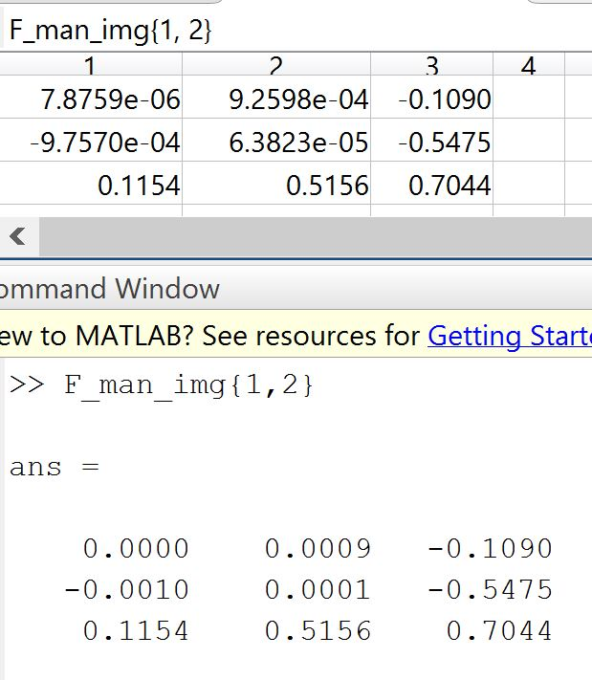

Image 3:

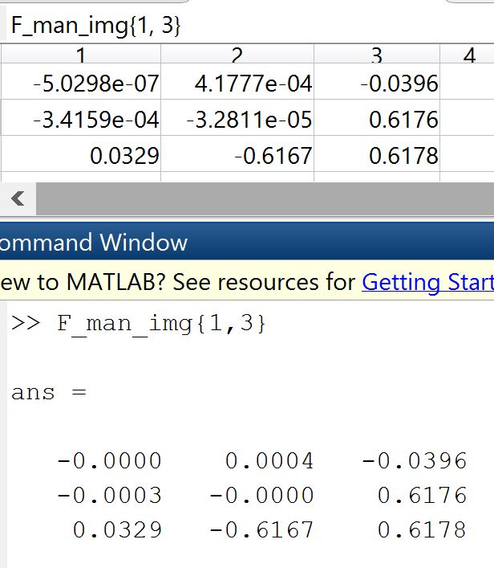

Image 4:

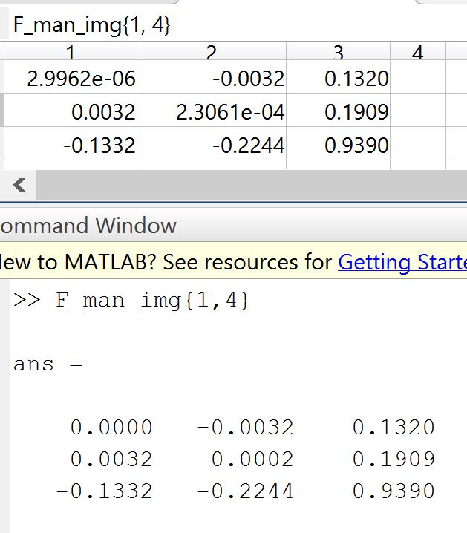

Image 5:

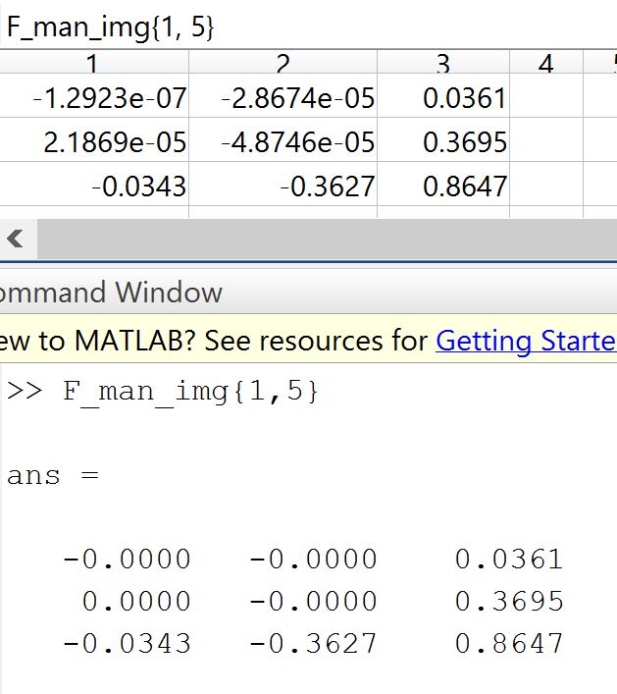

*Part 2 – 5 Fundamental Matrices F*

Image 1:

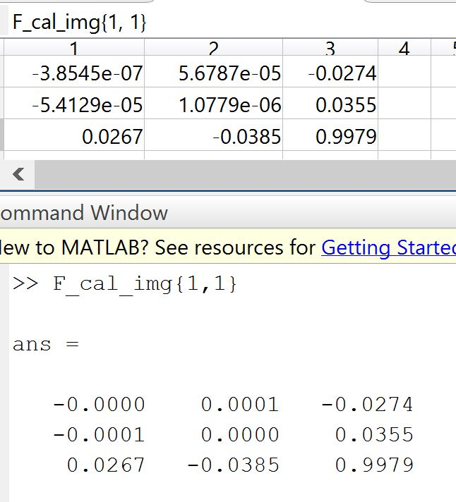

Image 2:

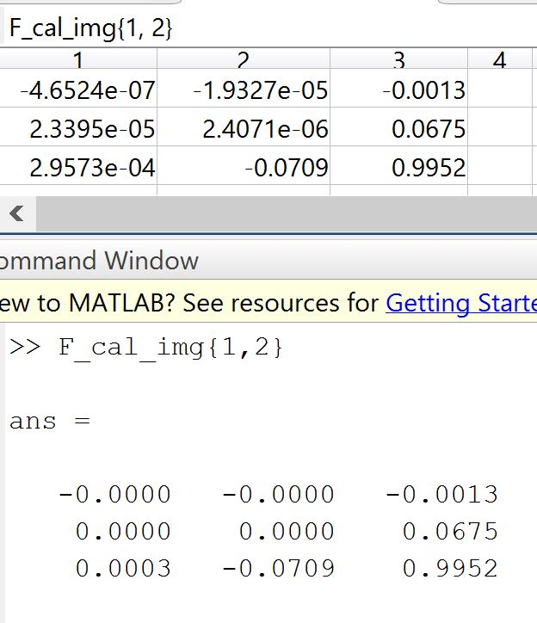

Image 3:

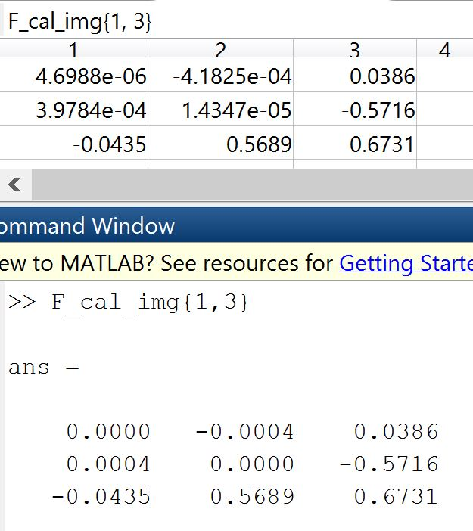

Image 4:

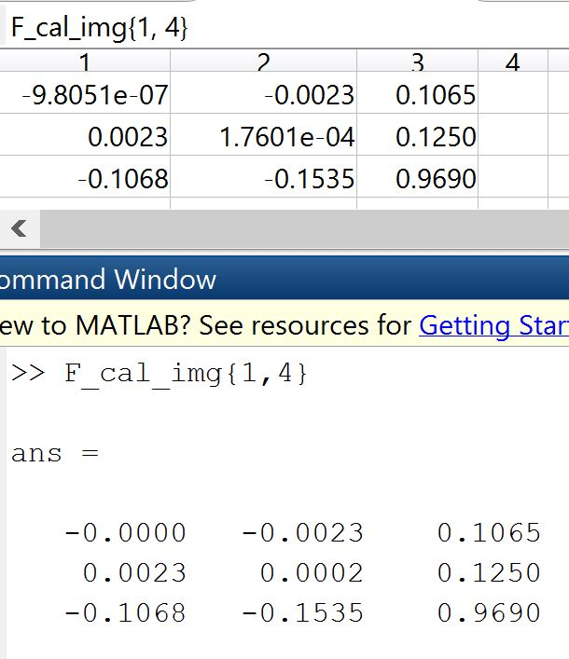

Image 5:

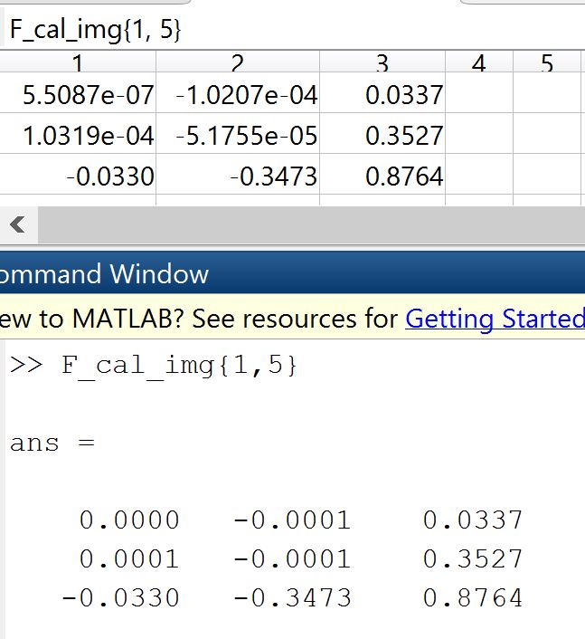

*Part 3 – 25 Figures with captions:*

**Step 3:**

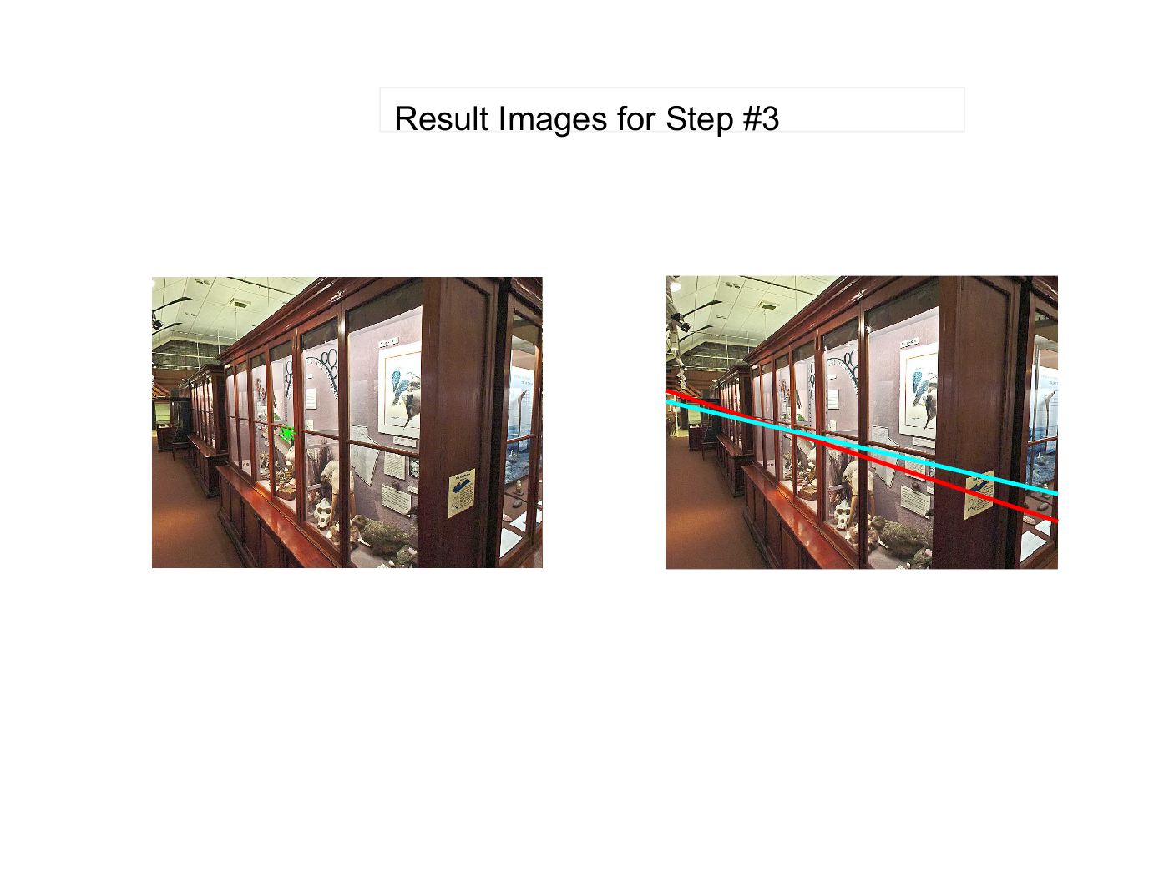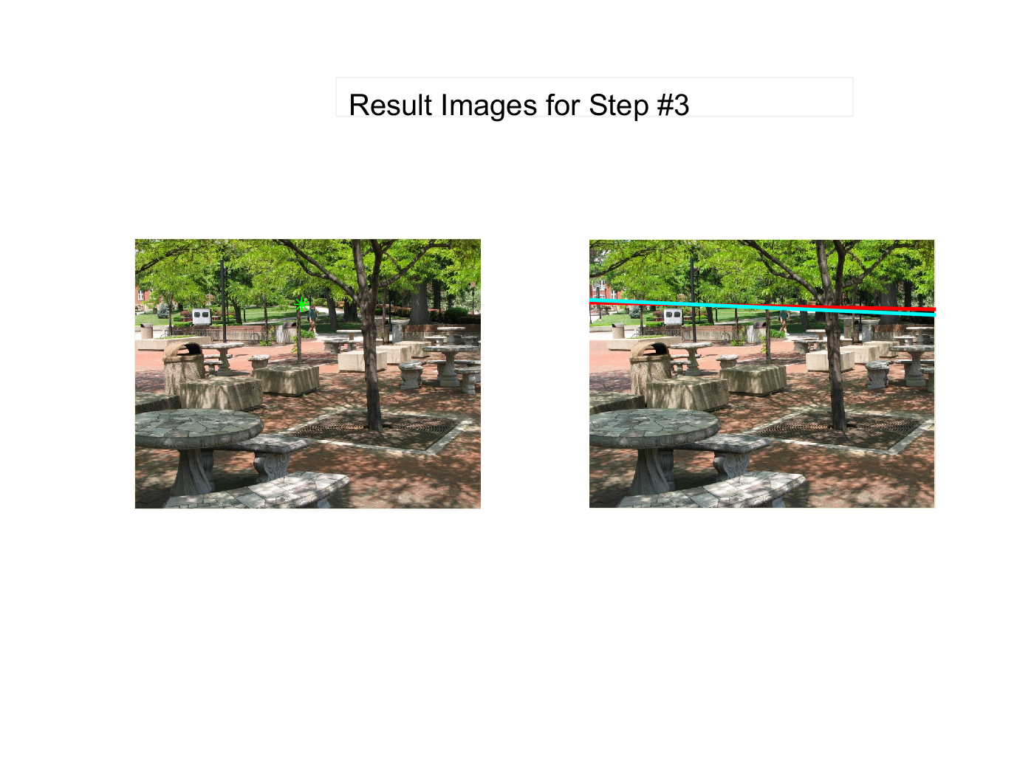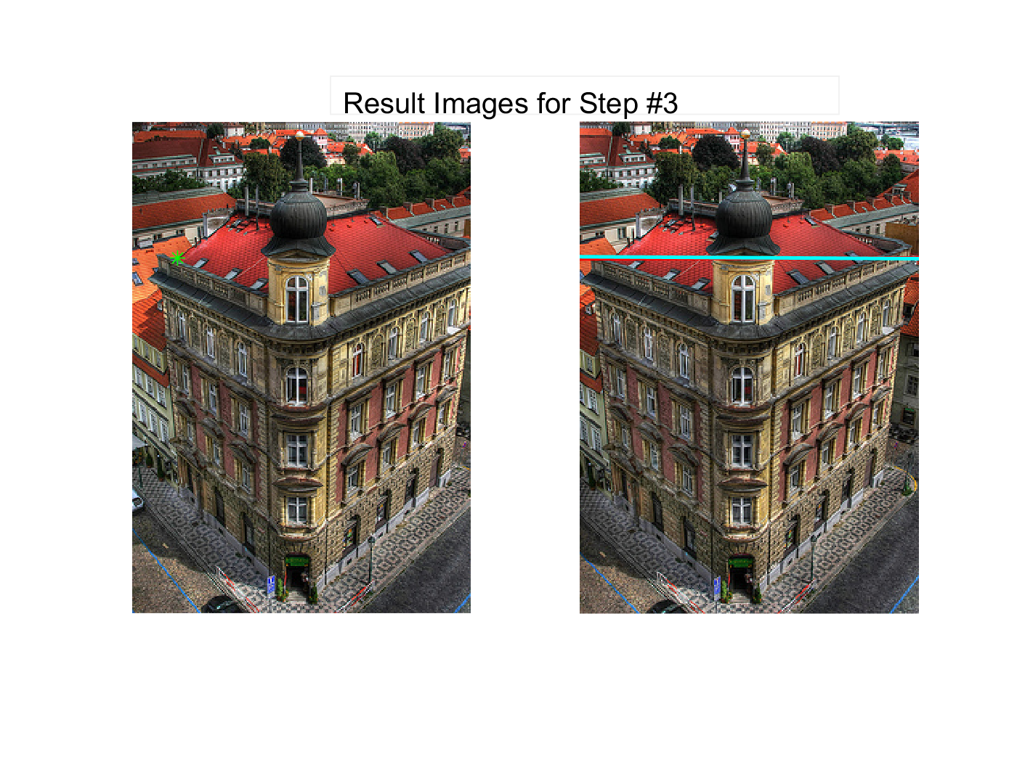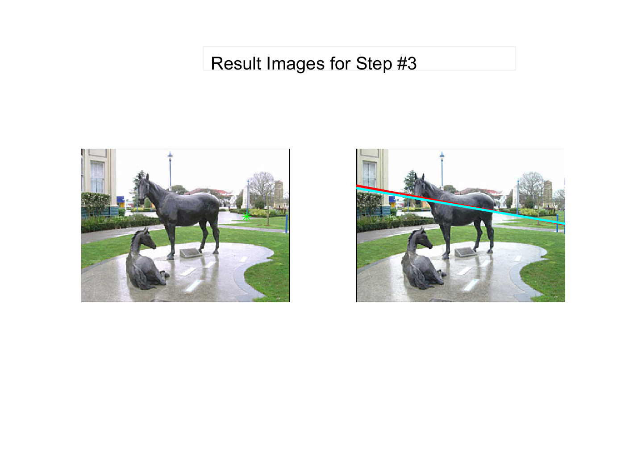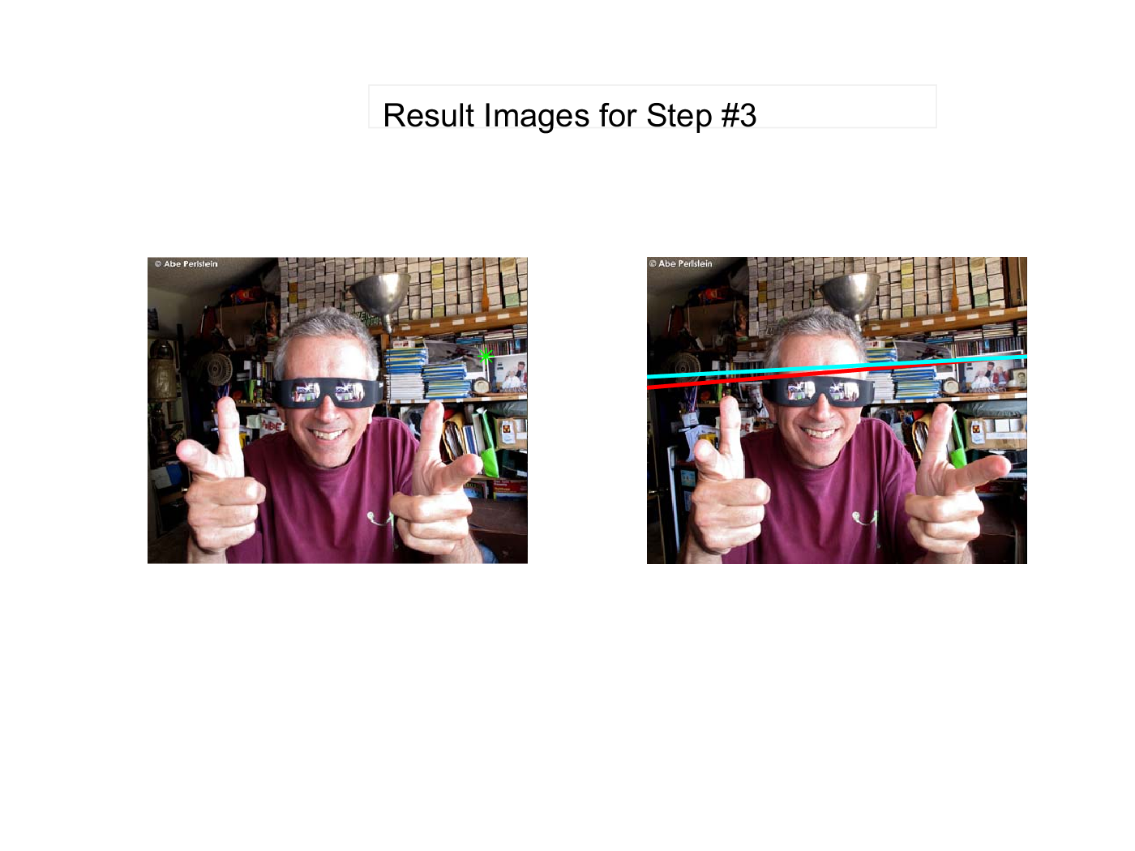

**Step 4:**

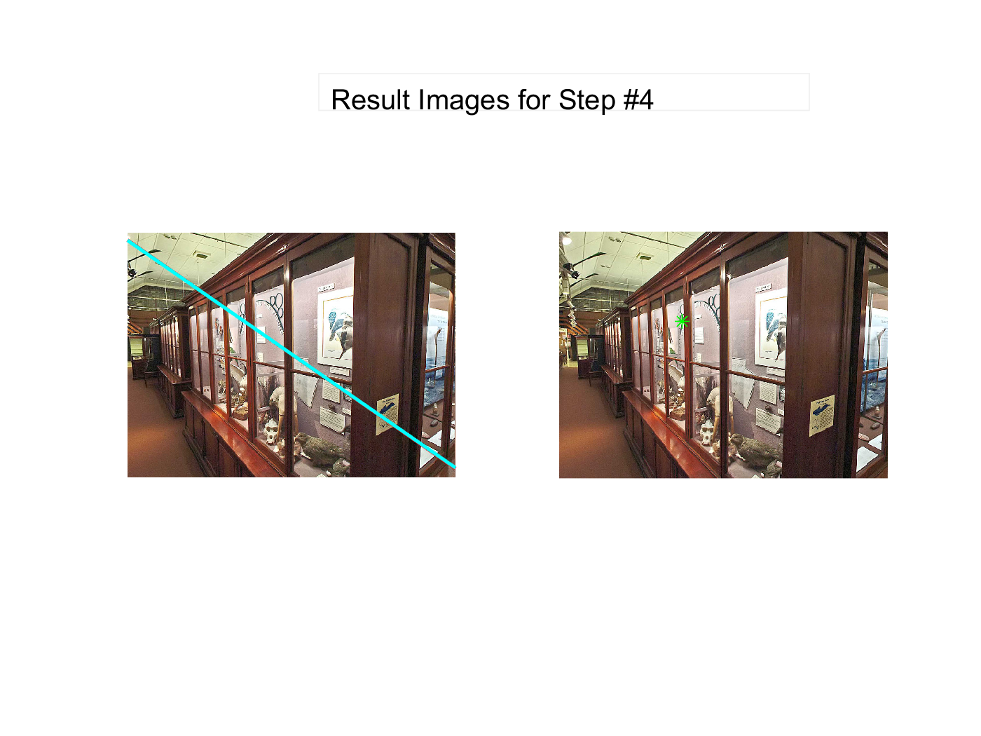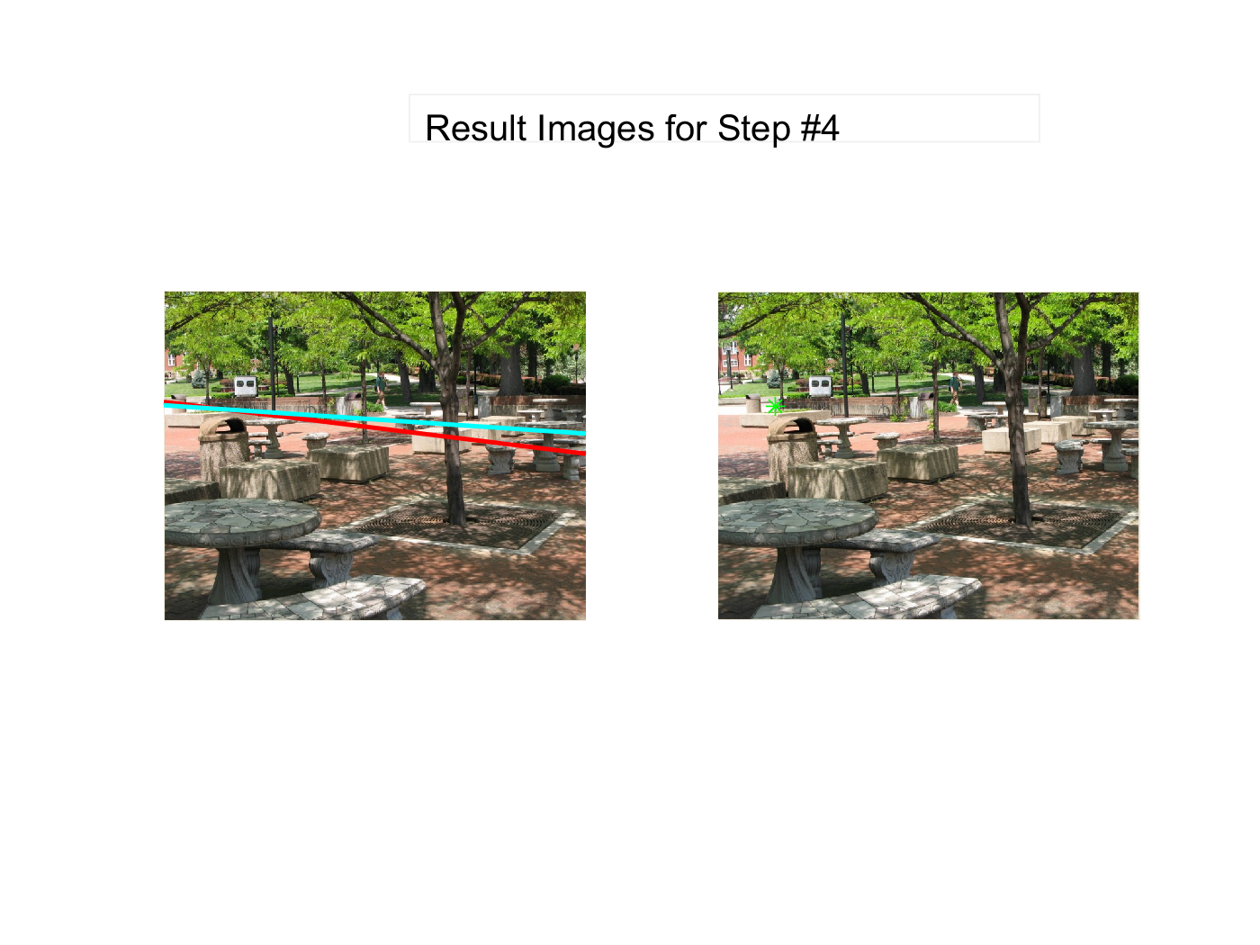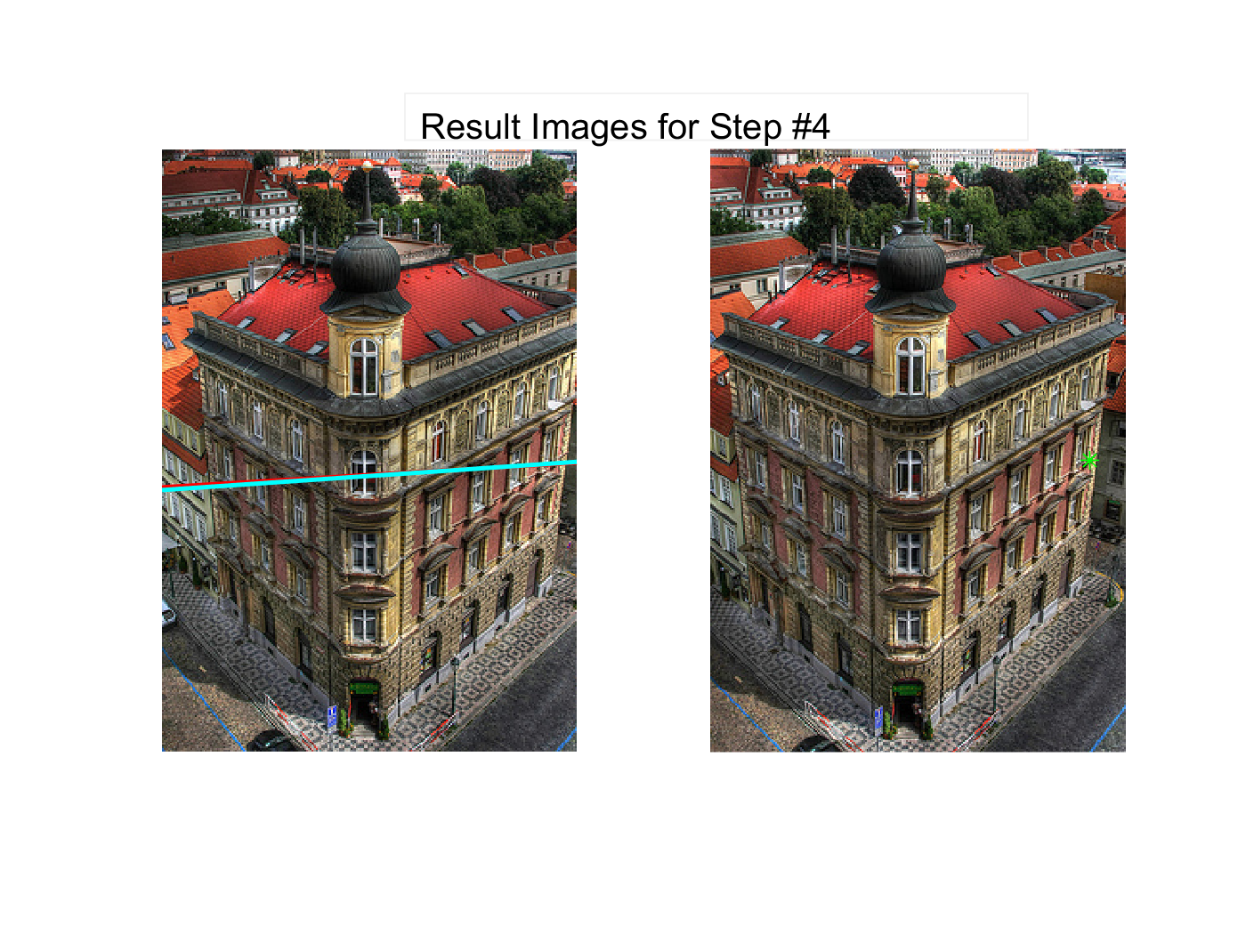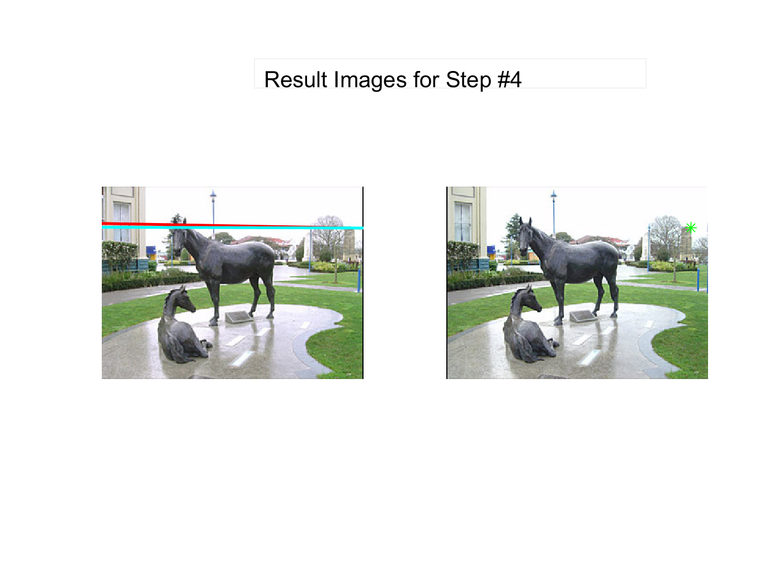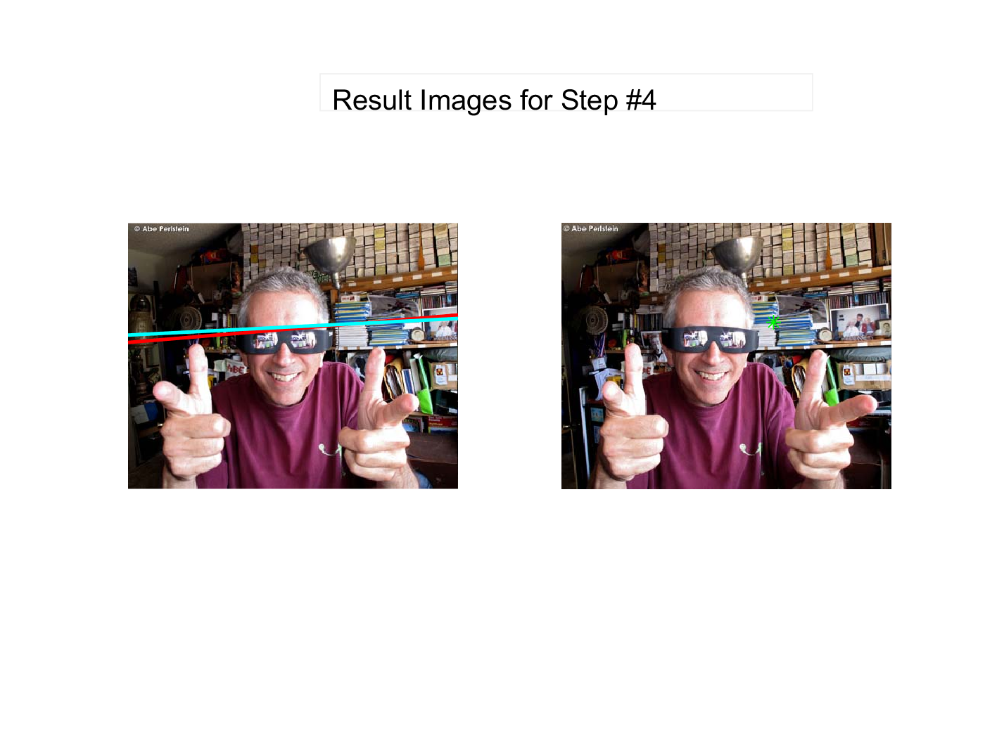

**Step 5:**

Calculated Coordinates:

|  |  |  |  |  |  |  |  |
| --- | --- | --- | --- | --- | --- | --- | --- |
| Image 1-1 | | | | Image 1-2 | | | |
| F(0) | | F' | | F(0) | | F' | |
| 764.8273 | 556.8592 | 561.3375 | 399.1108 | 710.8581 | 536.037 | 569.3432 | 398.3307 |
| Image 2-1 | | | | Image 2-2 | | | |
| F(0) | | F' | | F(0) | | F' | |
| -553.1 | 122.4494 | -564.68 | 113.7429 | -564.68 | 113.7429 | -389.675 | 74.77243 |
| Image 3-1 | | | | Image 3-2 | | | |
| F(0) | | F' | | F(0) | | F' | |
| 1798.84 | 97.04065 | 1143.148 | 170.3784 | 1483.496 | 94.19981 | 1011.638 | 169.0015 |
| Image 4-1 | | | | Image 4-2 | | | |
| F(0) | | F' | | F(0) | | F' | |
| -63.1276 | 41.65045 | -37.1038 | 58.19529 | -67.8517 | 42.00218 | -38.1897 | 58.60902 |
| Image 5-1 | | | | Image 5-2 | | | |
| F(0) | | F' | | F(0) | | F' | |
| -13952 | 1321.283 | -144542 | 12768.49 | -15161.3 | 1478.145 | 18710.45 | -1579.6 |
|  |  |  |  |  |  |  |  |

Image 1:

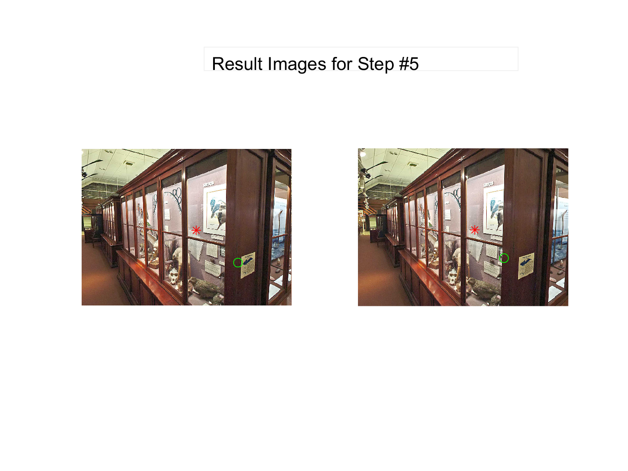

Image 2:

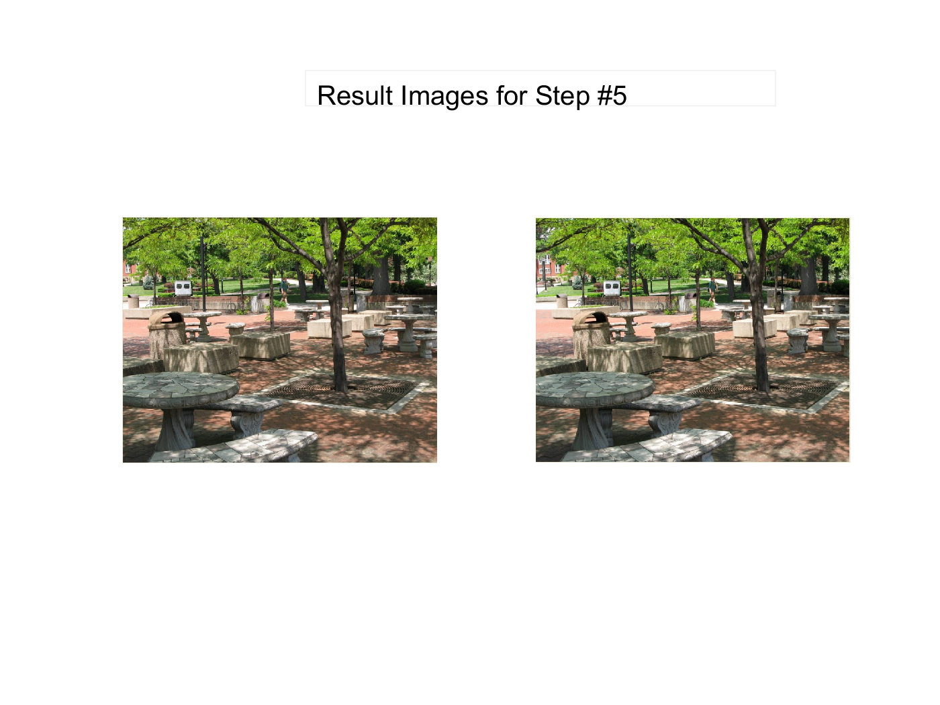

Image 3:

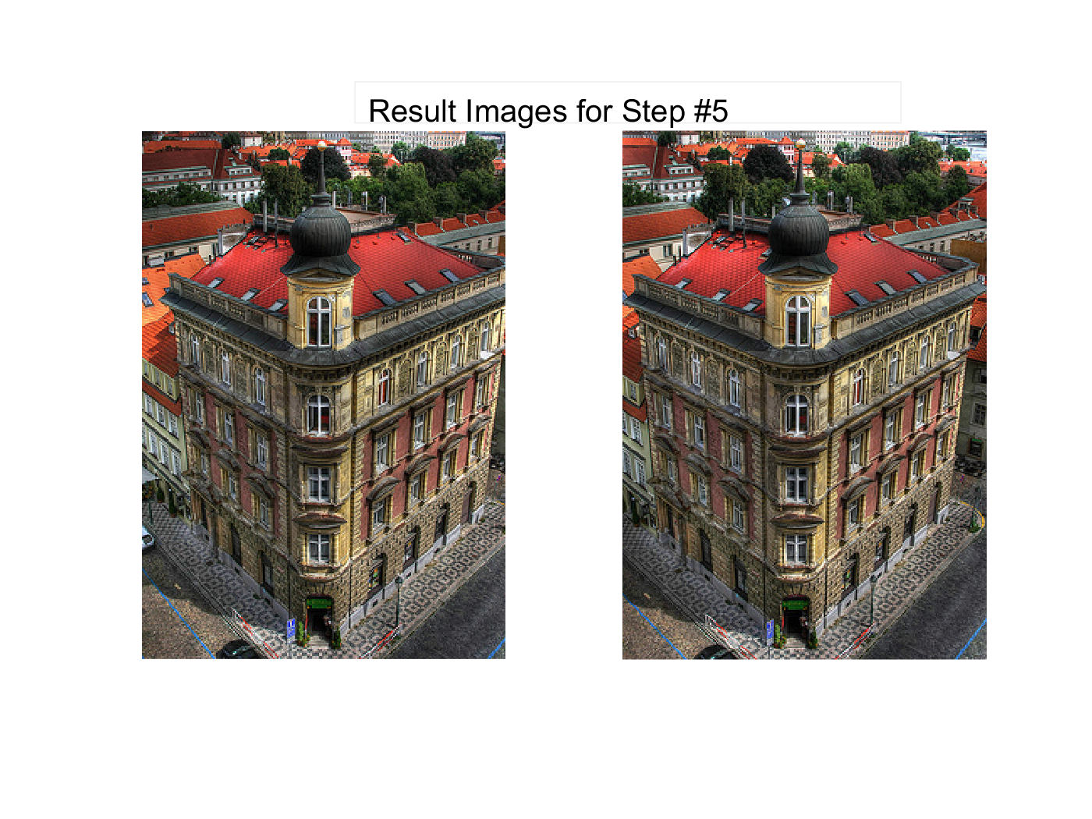

Image 4:

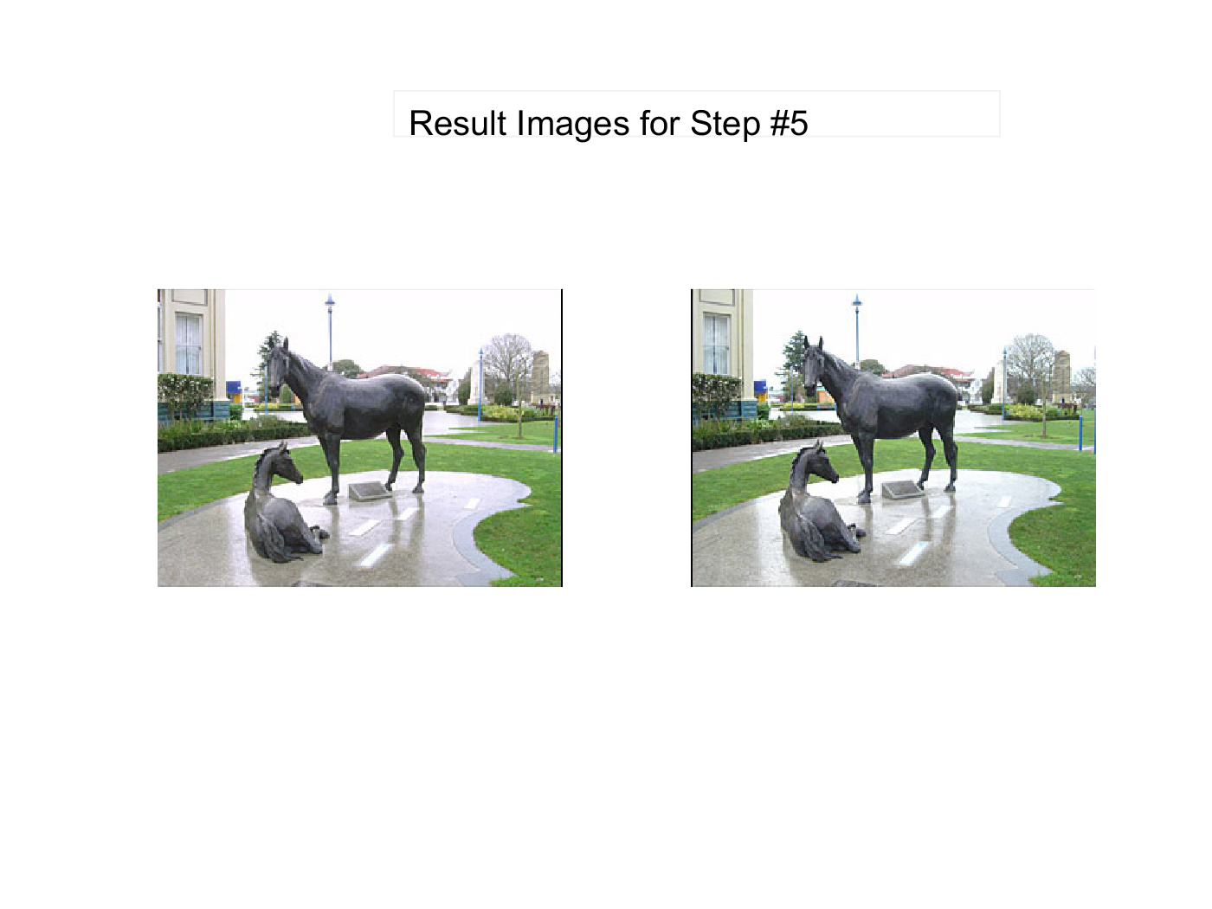

Image 5:

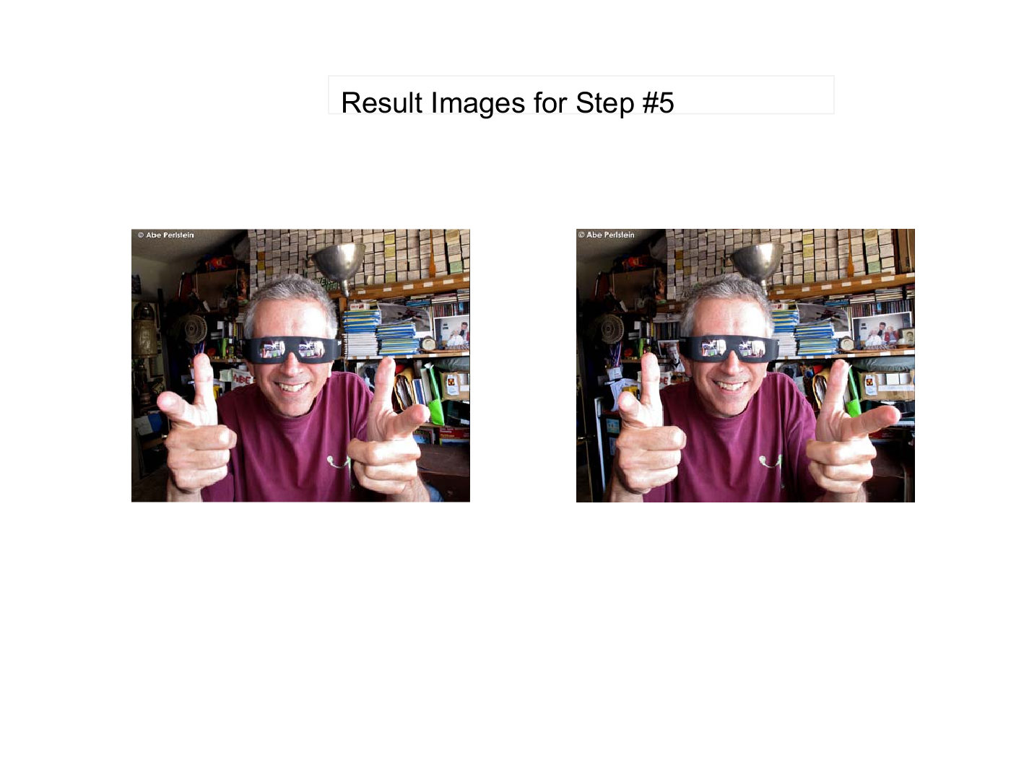

*Part 4 – Printout of Software:*

Matlab